Repository Profile:

Alternative Fuels Data Center

Marissa Fischer

LIS 545: Data Curation I: Fundamentals

February 9, 2024

The [Alternative Fuels Data Center (AFDC)](https://afdc.energy.gov/) is a data repository hosted by the United States Department of Energy’s Office of Energy Efficiency and Renewable Energy. It was released in 1991 in response to legislation surrounding alternative fuel and the Clean Air Act Amendments of 1990 and hosts a variety of data centered around advanced transportation technologies. The repository stores and presents data, maps, publications, case studies, etc., to track alternative energy measures and support the case for reduced petroleum use in the United States.

The AFDC is best suited for hosting Washington State’s *Electric Vehicle Population Data* because of the existing content and focus of the repository. Existing data on the AFDC site includes profiles by state, including one for Washington, with fueling station data, laws impacting the use of alternative fuels, fuel compensation over time, 2022 vehicle registration totals, etc. Figure 1 below is a snapshot of Washington’s profile page and the visualizations that the National Renewable Energy Laboratory (NREL) creates based on the data compiled in the repository.

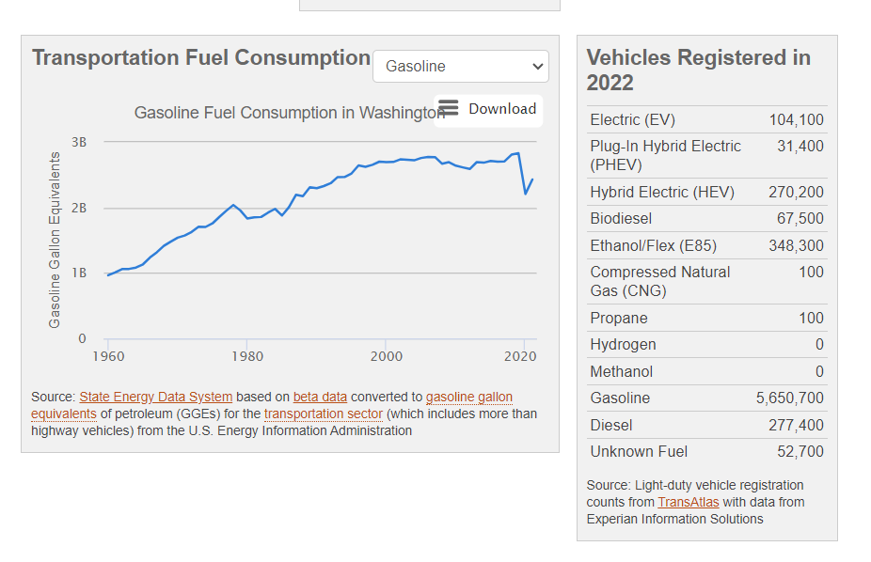

Fig. 1: Example of information provided on Washington’s profile in the AFDC Repository.

Other general visualizations are included in the repository, covering information for all of the United States, such as [*Electric Vehicle Registrations by State*](https://afdc.energy.gov/data/10962), but they do not go into detail about the models registered or the trends outside of the previous year’s data. The incorporation of *Electric Vehicle Population Data* into the AFDC repository would help supplement the more generalized information on the site to help improve the ability to draw connections between renewable energy data within Washington and with other states across the country.

The AFDC repository does not accept submissions from anyone, as their data is gathered from projects completed in the National Renewable Energy Laboratory (NREL) and by partners of the Clean Cities coalition. Projects from outside these groups can apply to receive funding and data publication through their project assistance program that is offered with Clean Cities. Each piece of data featured in the repository comes from a different source that has been analyzed by the NREL. The visualization mentioned in the above paragraph, *Electric Vehicle Registrations by State*, is an example of this, as it is cited as coming from the National Renewable Energy Laboratory with data collection by Experian Information Solutions.

No account is needed to download or view the data, but there are certain steps to go through to get access to the raw metadata that is used and stored in the repository. On the AFDC site, visualizations and other data have the option to be viewed as a graph, image, etc., or be downloaded as an Excel file directly from the page they are being viewed from. These Excel downloads are not datasets, but lists of the values, totals, etc., used to create the corresponding visualization, including the visualization that was generated to represent the data. For the full dataset of all records contributing to the analysis presented in AFDC, a separate webpage can be navigated to and the form (shown in Figure 2 below) needs to be filled out before being able to download the data. Datasets for fuel stations, laws, and vehicle registrations can be downloaded through this form submission as a CSV file, but the download does take a long time depending on the different options that were selected on the form. There seems to be no approval or waiting period and AFDC indicates that the collection of contact and use information is for tracking the use agreement conditions listed in the terms that are linked on the form.

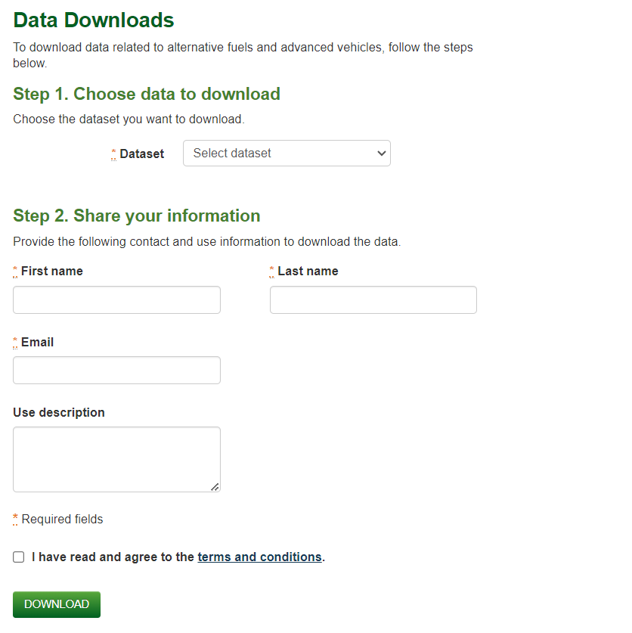

Fig. 2: Basic form for downloading datasets as .csv files from AFDC.

A sample of the data in the repository was downloaded using the form provided on the AFDC site, focusing on light-duty vehicle registrations for Battery Electric Vehicles and Plug-in Hybrid Electric Vehicles (the types of vehicles featured in *Electric Vehicle Population Data*) for all makes and models for 2021. The form does not allow the query to be drilled down to a specific state or region and upon looking at the dataset that was downloaded, no indication of location is given for any of the records. It is not clear if this data does not exist in the AFDC or if it is not available for download because it is considered “identifying information” that the data use terms prohibit. This method of direct file download is the only option provided on the repository and no metadata standard is given. The page for AFDC on re3data.org does have a link to a “data citation guideline” for the repository on Energy.gov, but when clicking the link, it results in an access denied page.

As a whole, the Alternative Fuels Data Center is a suitable home for the specific focus of the *Electric Vehicle Population Data* dataset, but it is by no means a perfect repository. The scope and potential for use for government departments is aligned for both the repository and dataset, but the non-existent submission access does make it difficult for datasets to be added to AFDC. While this may pose a problem for expanding data in AFDC in the future, *Electric Vehicle Population Data* is a dataset published by a state government, with connections to the U.S. Department of Energy, so it should be fairly easy for Washington to have this data uploaded to AFDC.

**References**

Alternative Fuels Data Center (2023, July). *Electric Vehicle Registrations by State*:

AFDC.Energy.gov: U.S. Department of Energy. <https://afdc.energy.gov/data/10962>

Registry of Research Data Repositories. *Alternative Fuels Data Center:* re3data.org.

<https://www.re3data.org/repository/r3d100010226>

Registry of Research Data Repositories. *Washington Transportation Data for Alternative Fuels*

*and Vehicles:* AFDC.Energy.gov: U.S. Department of Energy.

<https://afdc.energy.gov/states/wa>

Washington State Department of Licensing (2024, January 16). *Electric Vehicle Population*

*Data: Data.WA: State of Washington*. <https://data.wa.gov/d/f6w7-q2d2>